
TASKID: IN-TA-TPG-1459
STUDENT PERFORMANCE ANALYSIS SYSTEM
The Student Performance Analysis System is a web-based application designed to evaluate and enhance students’ academic performance through quizzes and analytical tools. In this system, students can register and log in by selecting their subject preferences. Based on these preferences, the system provides quizzes containing multiple questions, which students can attempt online. After submission, results are generated instantly, displaying marks, pass/fail status, and overall performance.
The system also includes a feature that allows teachers to upload descriptive questions, such as 6-mark and 10-mark questions. Students submit their answers in PDF format, which are then analyzed using predefined keywords to evaluate the content and extract key points. Based on this evaluation, subject-wise marks are calculated, and weak areas are identified.
Additionally, the system provides performance analytics through graphs and charts to help students track their progress over time. Reports are generated at multiple levels, including individual, subject-wise, and class-wise performance. These reports can be downloaded in formats such as Excel for further analysis.
Teachers can register, log in, upload questions, and monitor student performance using graphical representations and detailed reports. The admin module manages users, teachers, and overall system operations while providing access to comprehensive performance reports.
Overall, the system offers an efficient and intelligent solution for evaluating and improving academic performance.


Architecture
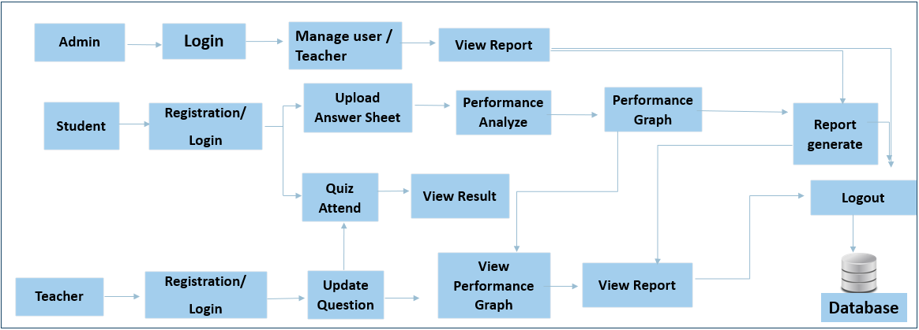


TECHNOLOGIES
- Front-End: HTML, CSS, JavaScript
- Back-End: Python
- Algorithm: NLP (For Answer Sheet Analyze)
- Framework: Flask
- Database: SQLite
- Tools: VS Code

